**Hypothesis and Data 10 pts: Respiratory Sinus Arrhythmia**

**\*\*PLEASE KEEP THE QUESTIONS WRITTEN IN YOUR ASSIGNMENT AND COMPLETE YOUR ANSWERS UNDER EACH PROMPT**.**

**Hypothesis:**

1. **How would you predict heart rate is altered during each inspiration and expiration? Explain.**

**Change -** HR increases with inspiration (shortened ECG, less vagal to heart) and decreases with expiration (prolonged ECG, more vagal to heart). **Caused** by lung inflation 🡪 pulm stretch receptors 🡪 medulla 🡪 inhibition of vagal activity 🡪 increase HR.

** ***Consequence*** (not cause!!) is: The distribution of heartbeats within a respiratory cycle affects the efficacy of respiratory gas exchange by matching perfusion to ventilation within each respiratory cycle and limiting unnecessary heartbeats during expiration. This answer alone would not suffice, need **cause** (above).

1. **How would you predict the maximum to minimum range of heart rates observed during respiratory sinus arrhythmia at baseline will change with deep breathing? Explain.**

**Change –** The change/delta of the max minus in HR during the respiratory cycle would be increased. **Caused** by deep breathing stretching the lung sensory receptors more and amplifying the respnse 🡪 pulm stretch receptors 🡪 medulla 🡪 more inhibition of vagal activity 🡪 further increase HR compared to baseline.

** ***Consequence*** (not cause!!) is: The distribution of heartbeats within a respiratory cycle affects the efficacy of respiratory gas exchange by matching perfusion to ventilation within each respiratory cycle and limiting unnecessary heartbeats during expiration. This answer alone would not suffice, need **cause** (above).

**Screen Captures:**

1. **Screen capture of normal breathing data for all channels.**

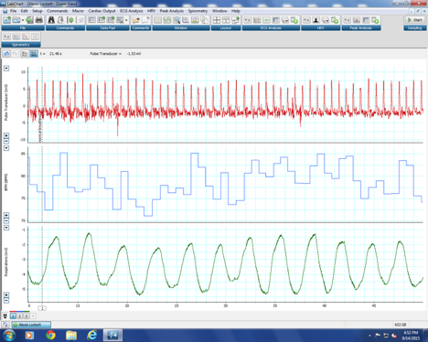

1. **Screen capture of deep breathing data for all channels.**

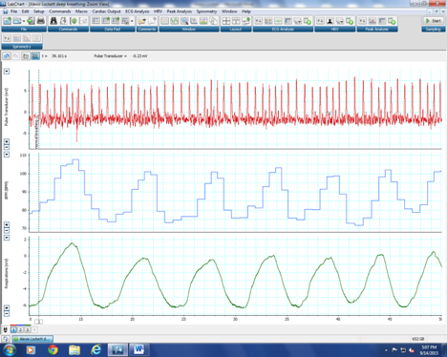

1. **Fill in the following information below to describe the data for the screen captures of your normal and deep breathing above.**
2. **One sentence observation comparing normal (Figure 1) and deep breathing (Figure 2):**

**Deep breathing results in a more profound max to min oscillation is heart rate with respiration.**

1. **Channel 1: fill in the blank for each item**
2. **Physiological parameter displayed: pulse, finger pulse wave**
3. **Peripheral device used: pulse transducer**
4. **Y-axis unit of measure: mV**
5. **Raw data or calculated channel? Raw**
6. **Channel 2: fill in the blank for each item**
7. **Physiological parameter displayed: heart rate**
8. **Peripheral device used: pulse transducer**
9. **Y-axis unit of measure: beats per minute**
10. **Raw data or calculated channel? Calculated**
11. **Channel 3: fill in the blank for each item**
    1. **Physiological parameter displayed: respiration or rib cage movement**
    2. **Peripheral device used: respiratory belt**
    3. **Y-axis unit of measure: mV**
12. **Raw data or calculated channel? Raw data**

**Summary Class Pooled Data**

N=21

*P<0.01

Paired t-test, one tailed

**Based on the screen captures and summary graph, state 1-2 sentences to summarize the key findings of this experiment. Was this consistent with your hypothesis.**

**Deep breathing results in a more profound max to min oscillation is heart rate with respiration. Yes this was consistent with our hypothesis.**